Design principles & Patterns

Solution
Exercise 1: Implementing the Singleton Pattern
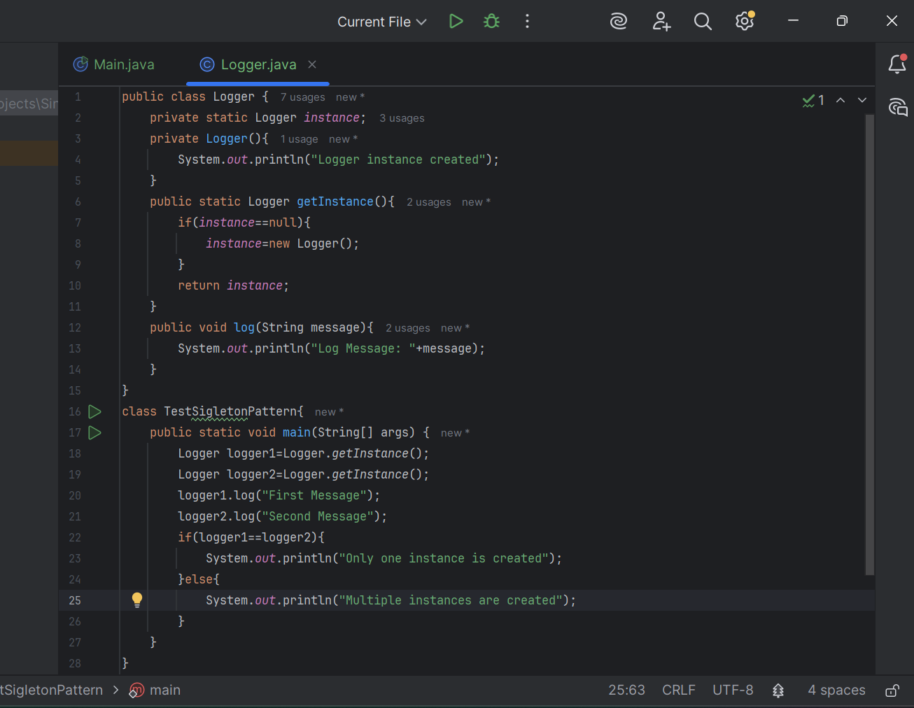
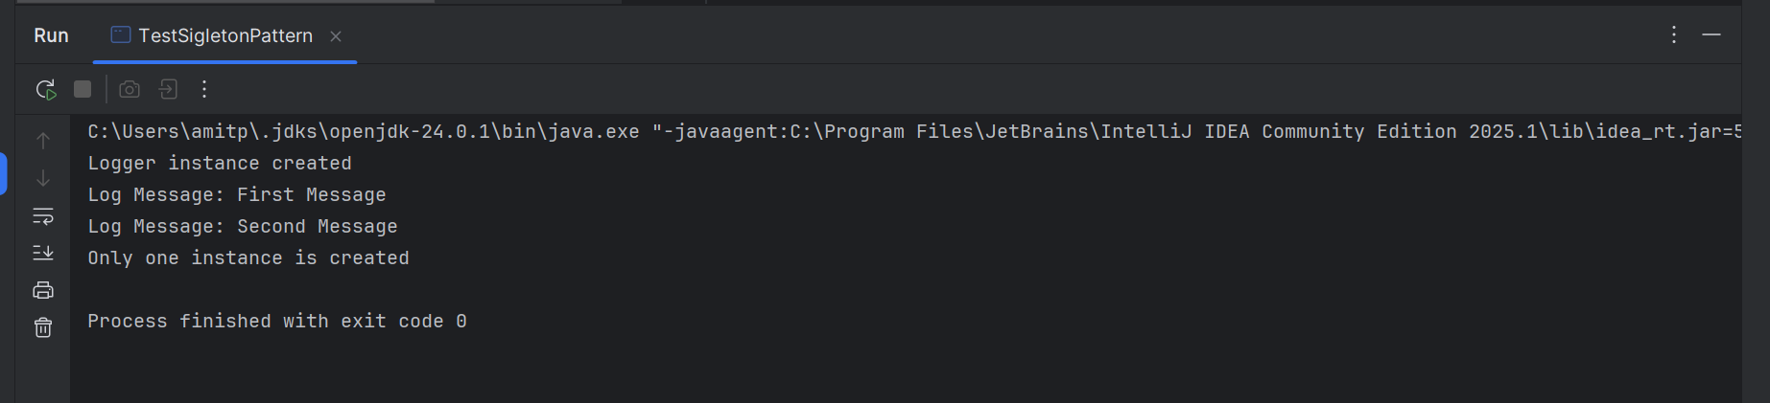

Exercise 2: Implementing the Factory Method Pattern
